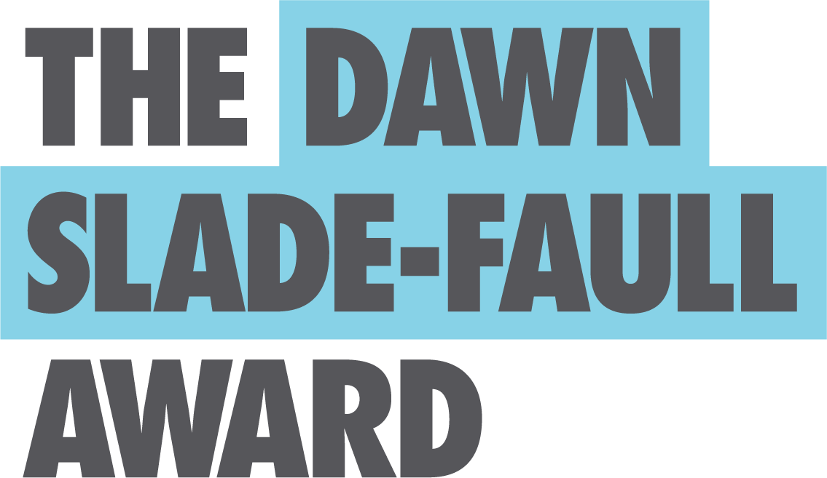

Media Release | DSFA 2020

Key Details
We are seeking entries and help with promoting the re-launch of the Dawn Slade-Faull Award in 2020. At a time when artists need support more than ever, we hope to extend our call for entries to everyone eligible to enter. Please help us to reach the artists in the South Australian community that would benefit from this timely opportunity.
Event | The Dawn Slade-Faull Award 2020 online exhibition of shortlisted artwork
Venue | Online @ www.dsfa.org.au, and linked in with the SALA Festival 2020
Key Dates | Award entries now open – close August 9th 2020
Online exhibition opens August 17th 2020 – winners announced August 17th 2020
Key Contact | Chris Faull, Chair of Trustees, e: chris@readymade.com.au, m: 0411 197 470
The Award
The Dawn Slade-Faull Award aims to empower South Australian emerging artists with a disability by providing financial support and encouragement to help them realise their potential in their chosen medium.
The Award aims to be flexible and respond to the changing needs of artists and the community. In 2020, the year of COVID-19 and social distancing, the Award will open with an online SALA exhibition showcasing the shortlisted artworks in August 2020 on the DSFA website.
The exhibition will conclude with a single Award of up to $3,000.
Entries may be made by, or on behalf of, any artist who is resident in South Australia and who has an intellectual, physical, psychiatric, cognitive or sensory disability.
Entries for the Award are accepted via the DSFA website. For artists requiring assistance with their submission, help is available from the DSFA award support staff (email help@dsfa.org.au).

With a history of supporting South Australian artists since 1988, we are excited to continue and grow our reach and support in 2020.

We really appreciate your support.
Trustees DSFA 2020

